**1.Set Up Azure Resources**

Screenshot of the Azure portal displaying the creation of the resource group for the PetStoreApp

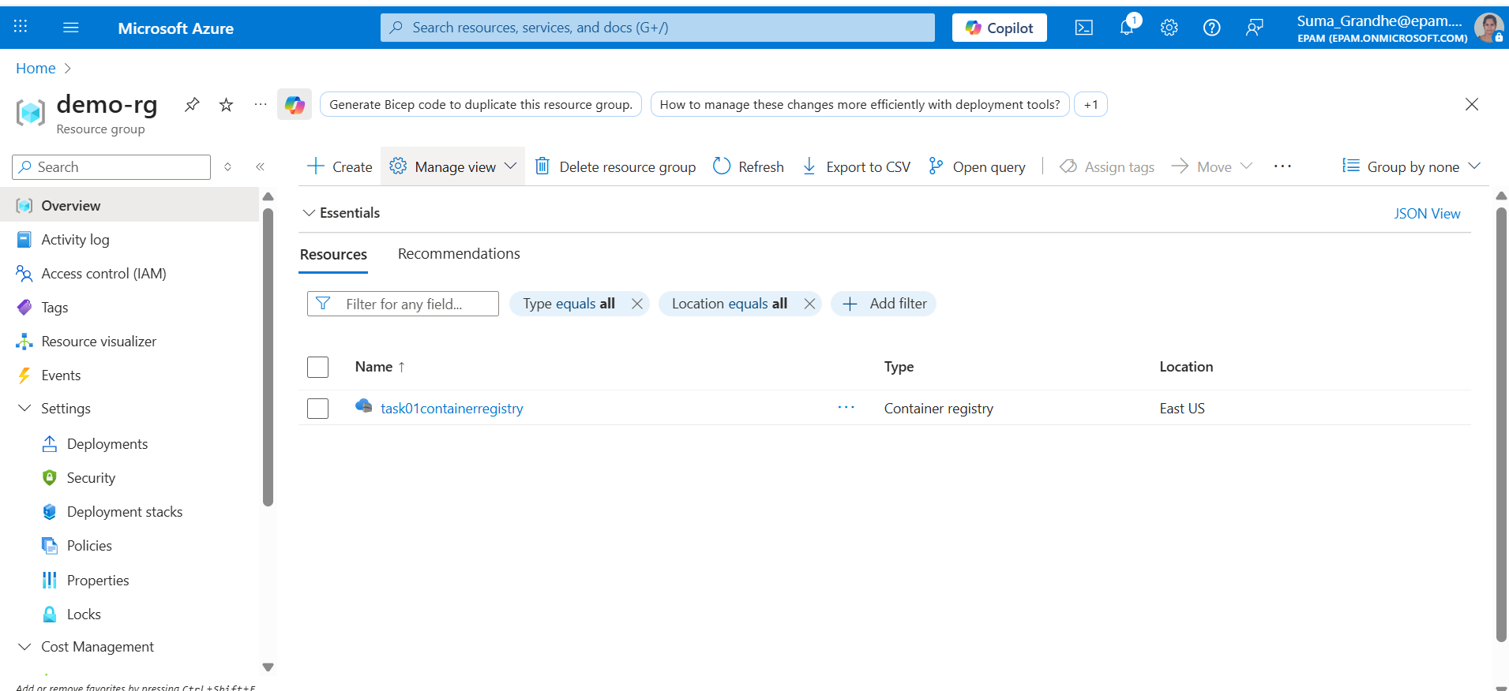

Screenshot of the successful creation of the Azure Container Registry (ACR).

Screenshots documenting the Docker image build and push process to the ACR.

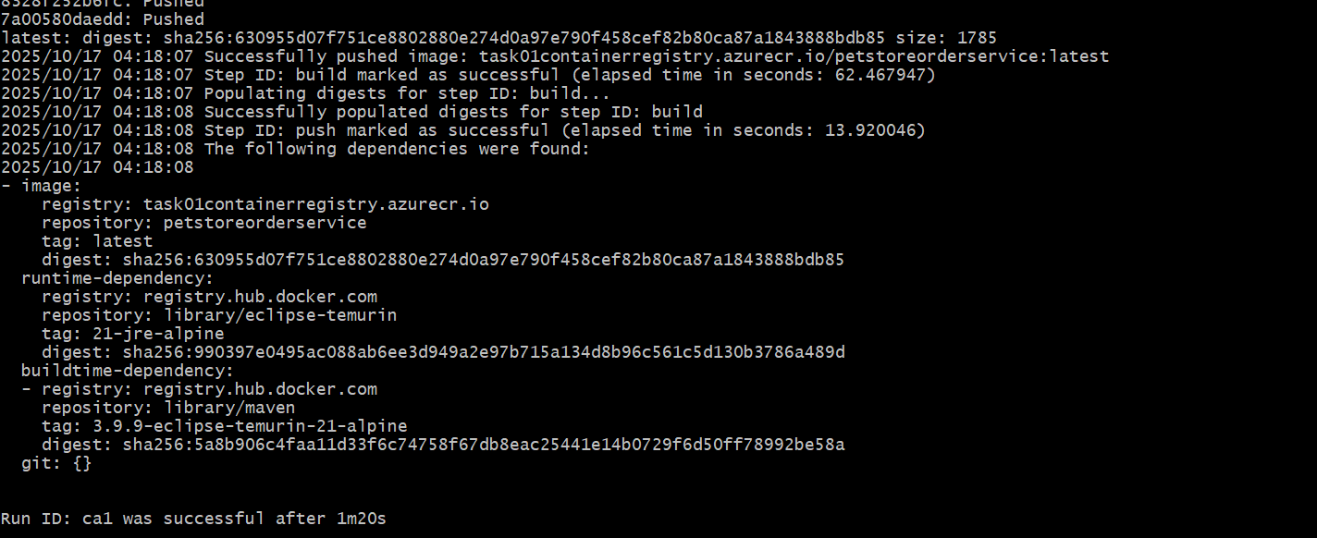

Screenshot of 4 repositories in ACR: task01containerregistry

**2.Deploy Services to Azure App Services**

Screenshot of the Azure portal Creation of App Service Plans for PetStoreApp (Web) and Public API Services

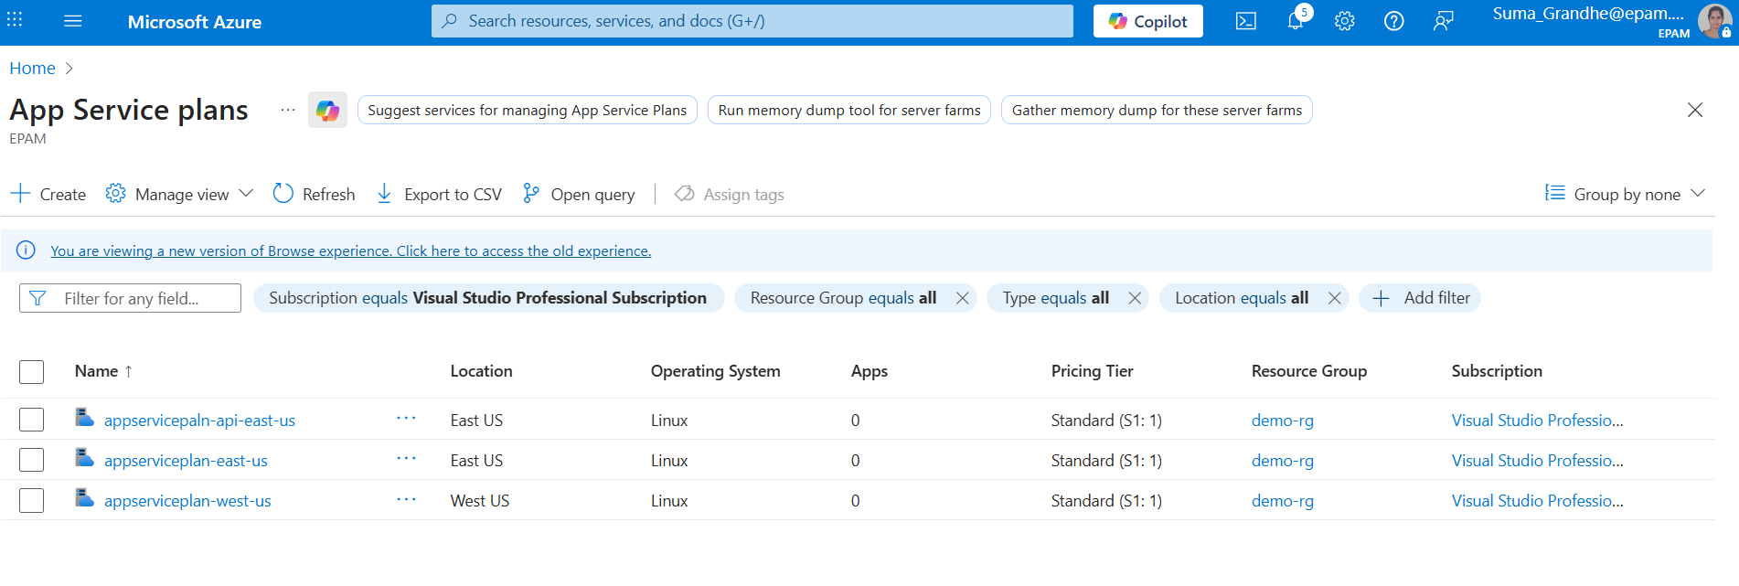

Screenshot of the Azure portal Deployment of PetStoreApp (Web) to two different regions.

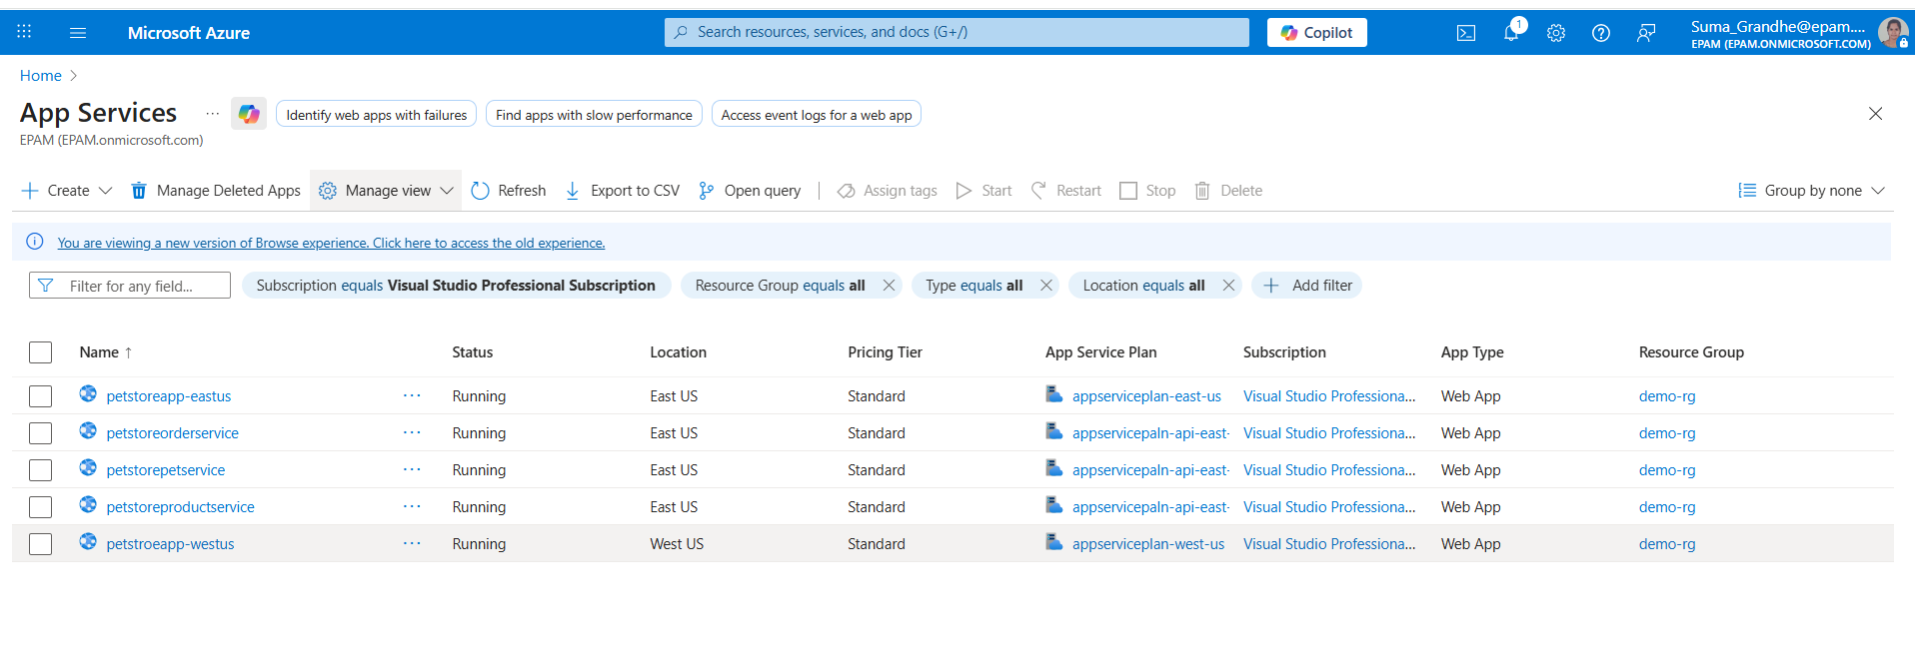 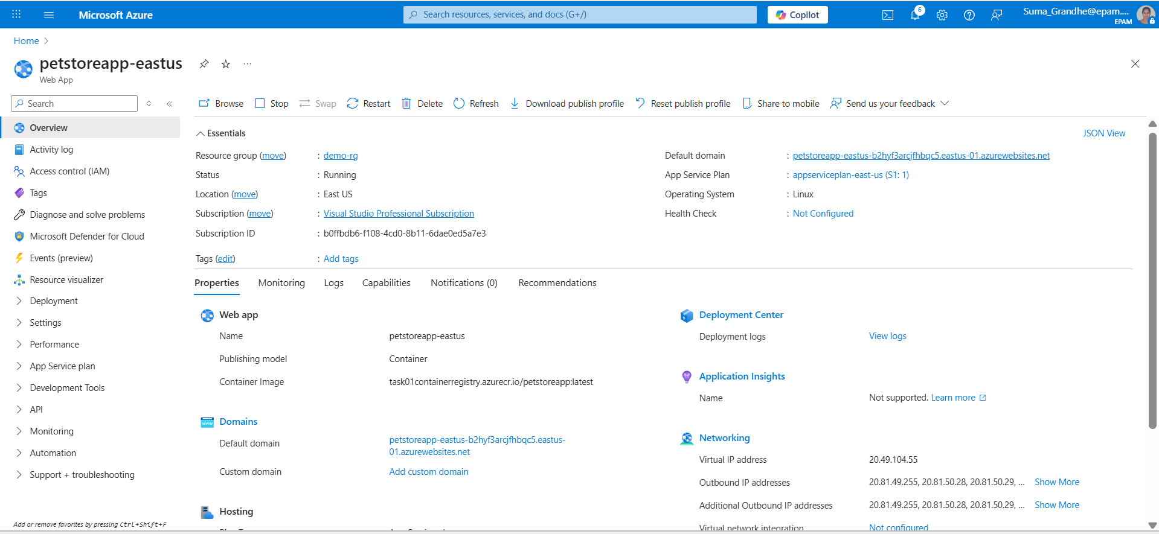

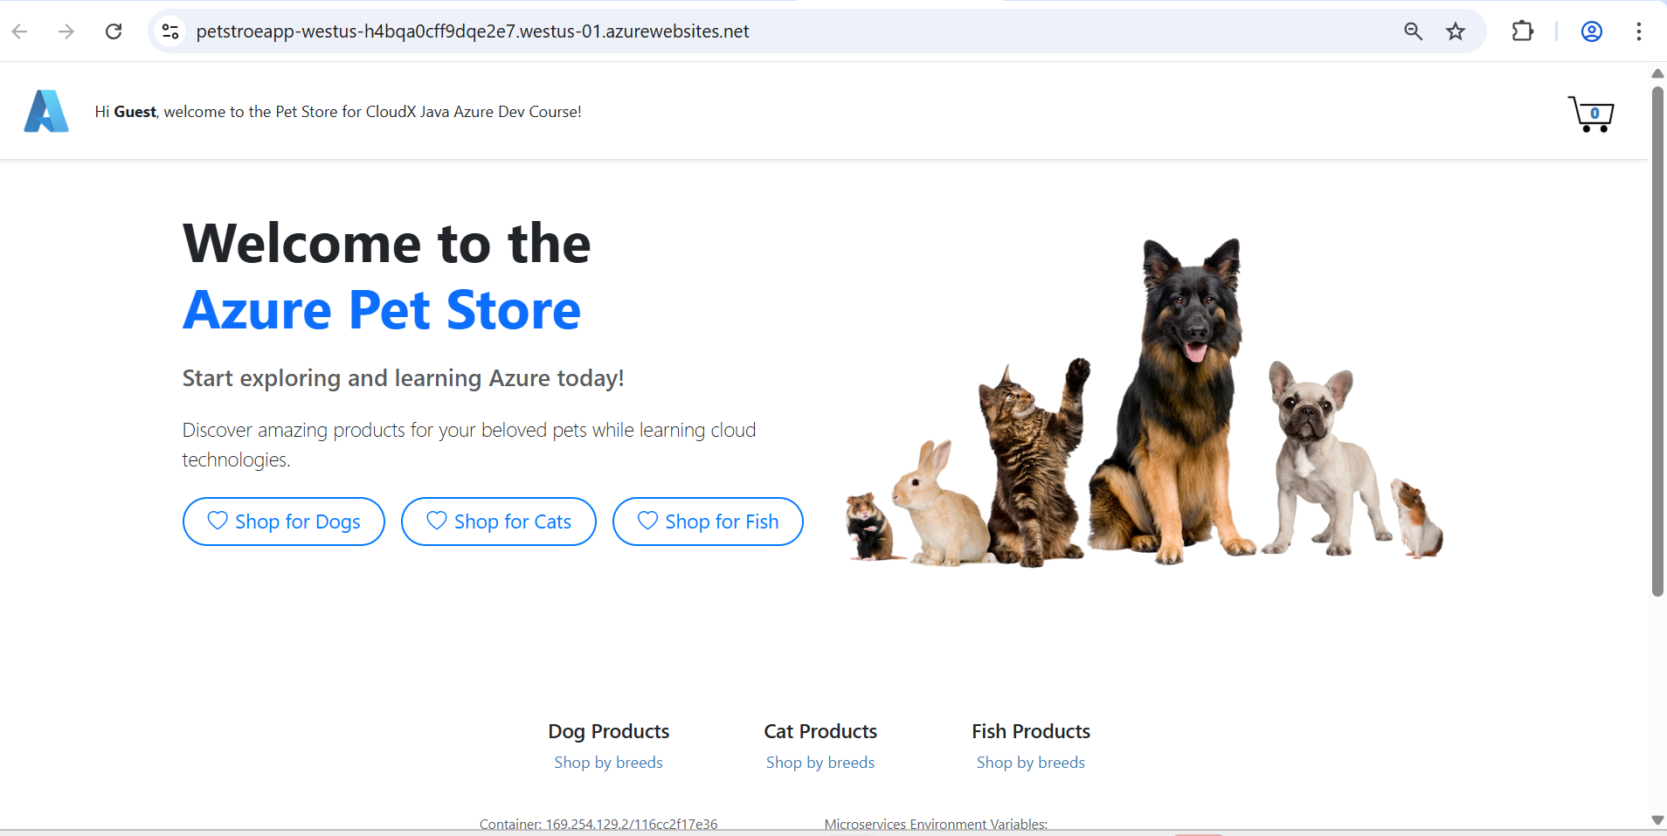

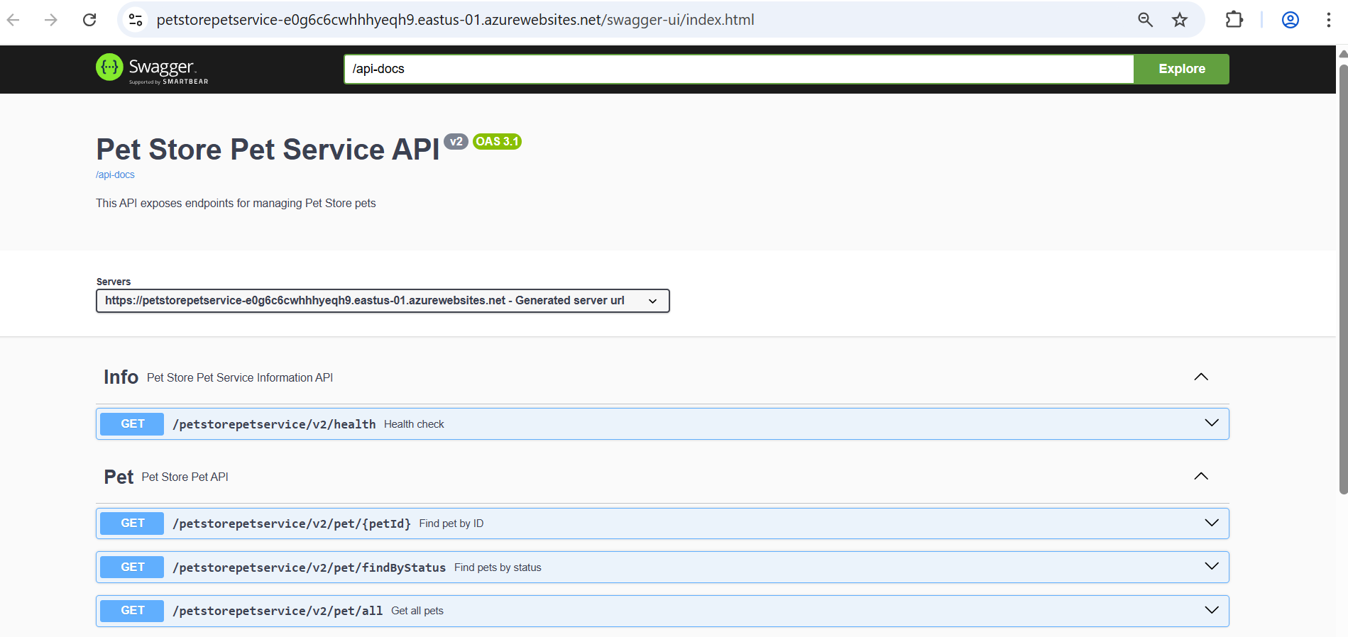

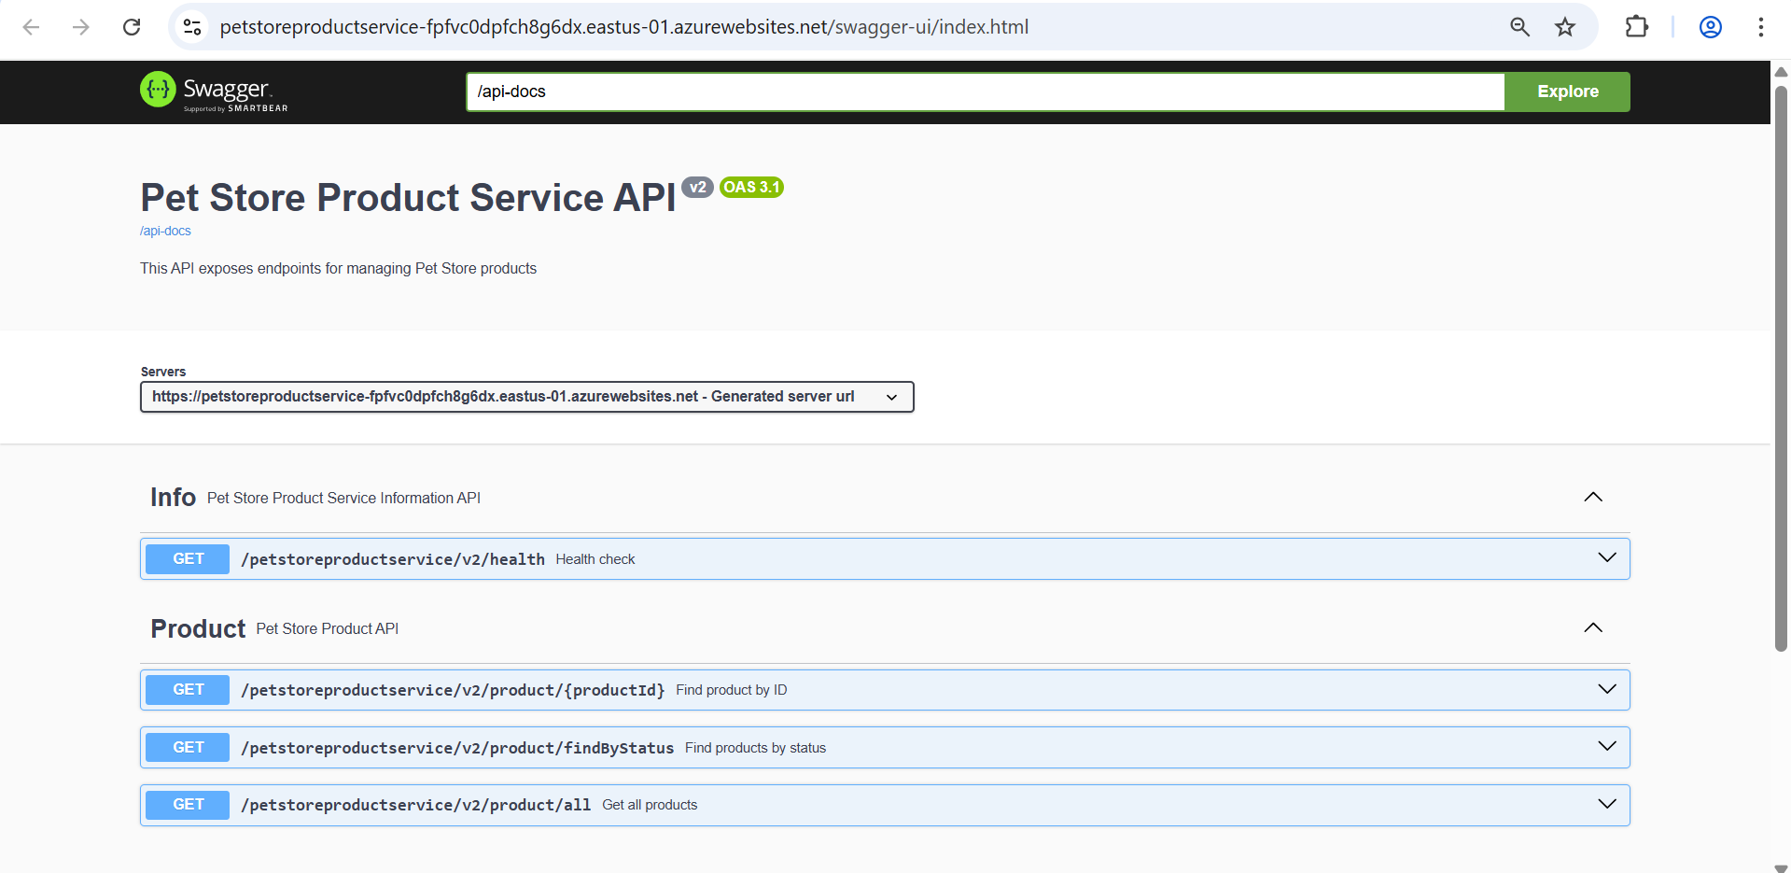

Screenshot of the Azure portal Configuration of environment variables for services communication

Video demonstrating successful navigation between pages without errors.



**3.Configure Auto-Scaling**

Screenshots of the Azure portal Configuration of rules-based autoscaling for public API services

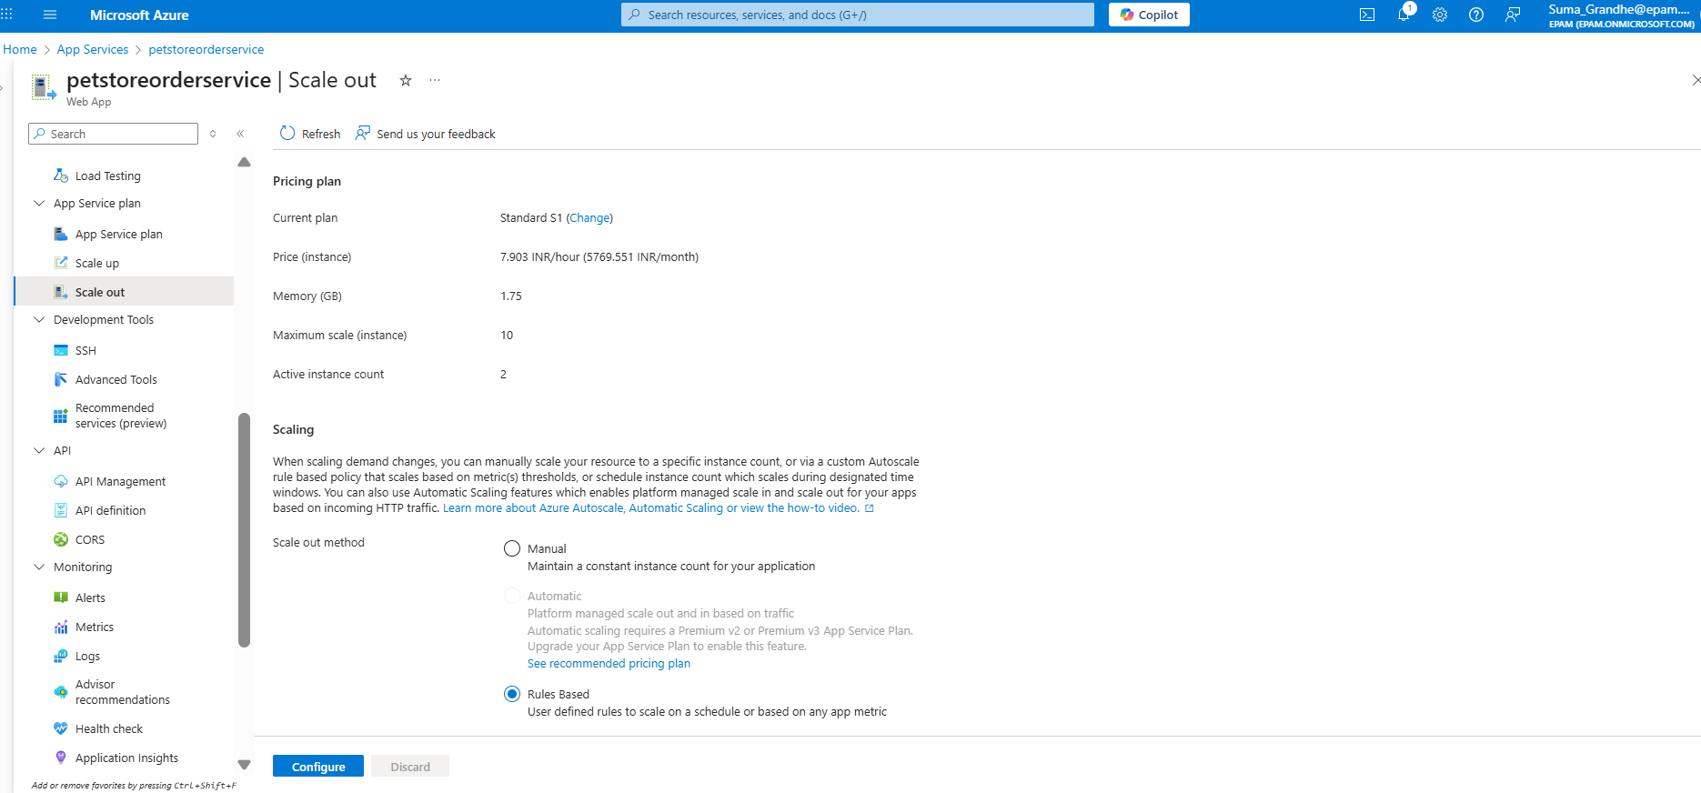

Screenshots of the Azure portal setup of custom autoscale settings, including CPU usage thresholds and Verification of autoscaling settings and rules.

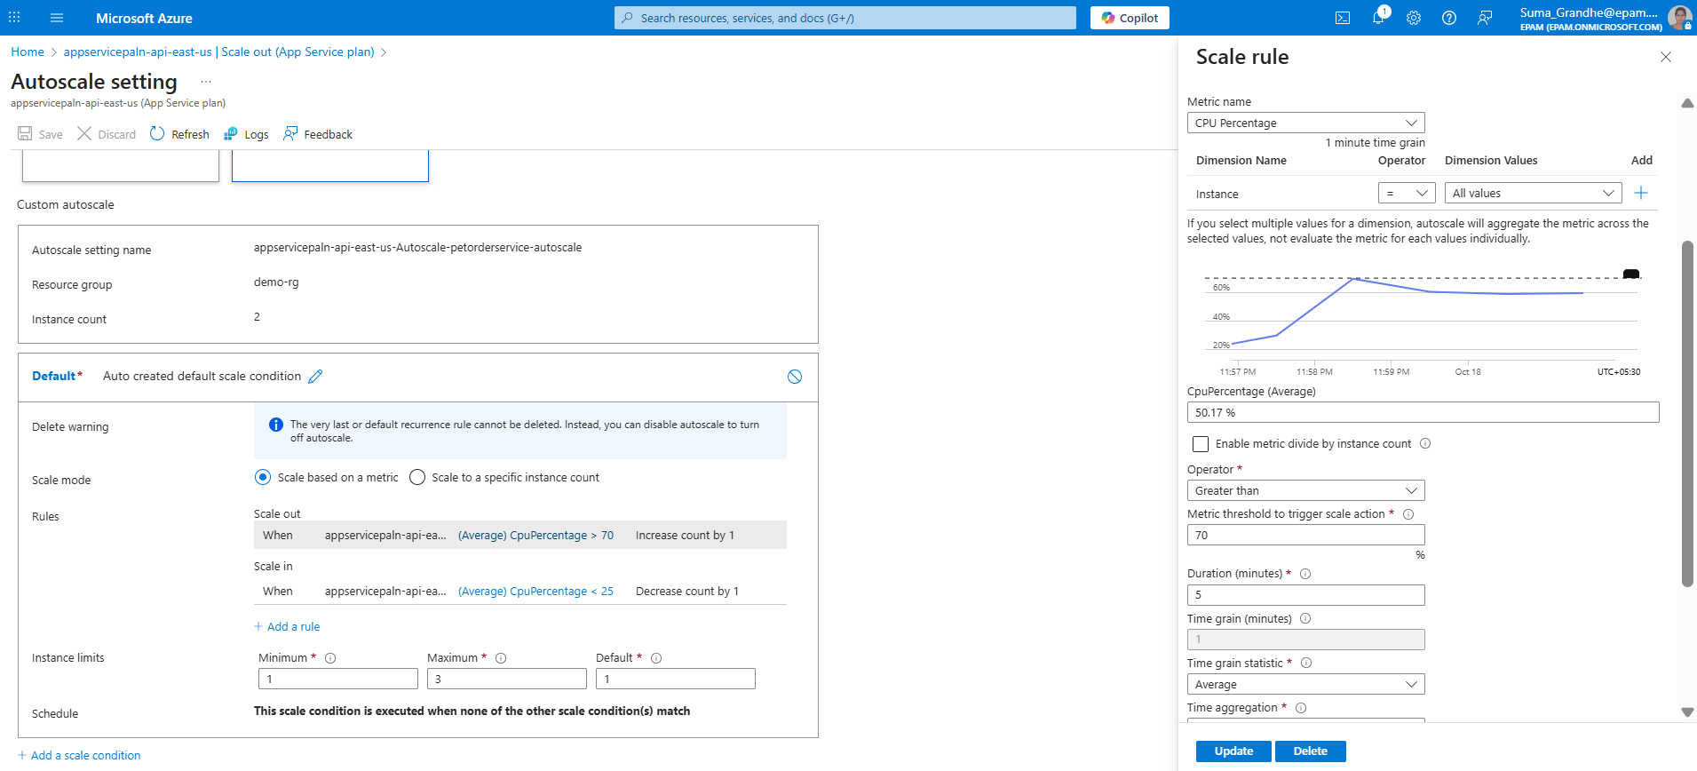

**4.Test Autoscaling using k6 Tool**

Screenshot of Swagger endpoints utilized for testing autoscaling

Screenshots of the k6 tool in use for testing autoscaling.

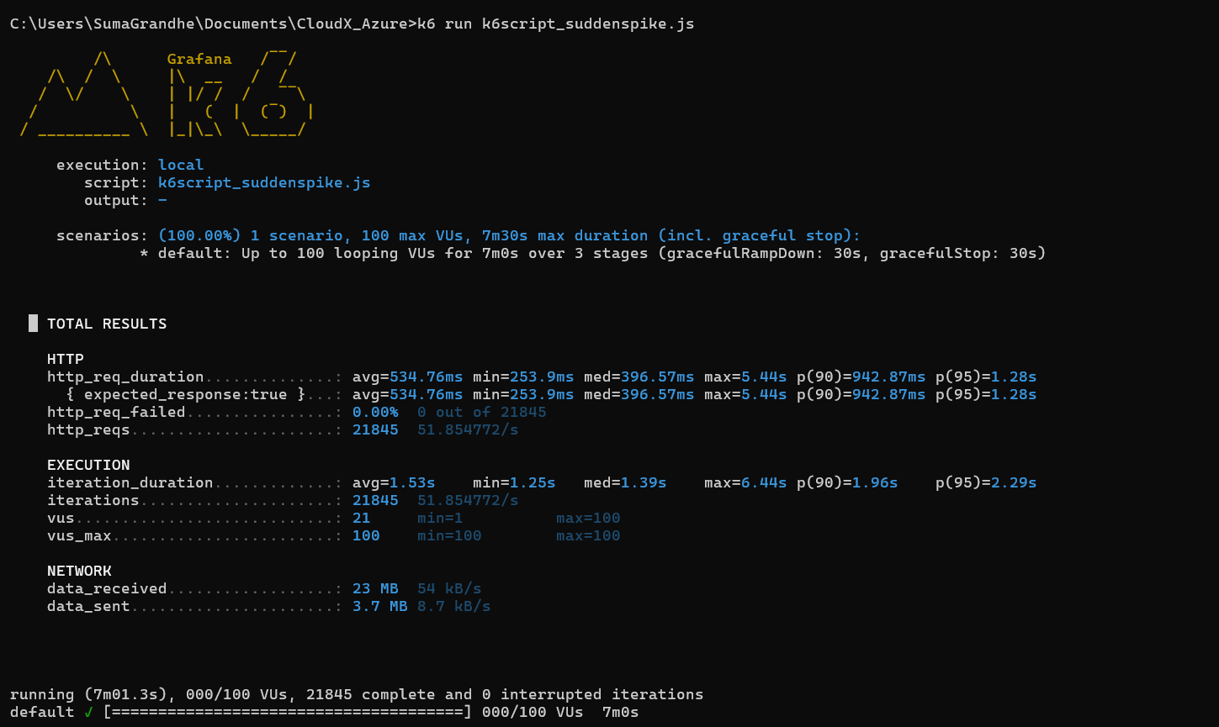

Screenshots of the results, particularly showing the scaling behaviour under load

**5.Set Up Deployment Slots for PetStoreApp**

Screenshot of Azure Portal creation of a deployment slot for PetStoreApp.

Screenshot of Azure Portal configuration of slot settings, including continuous deployment.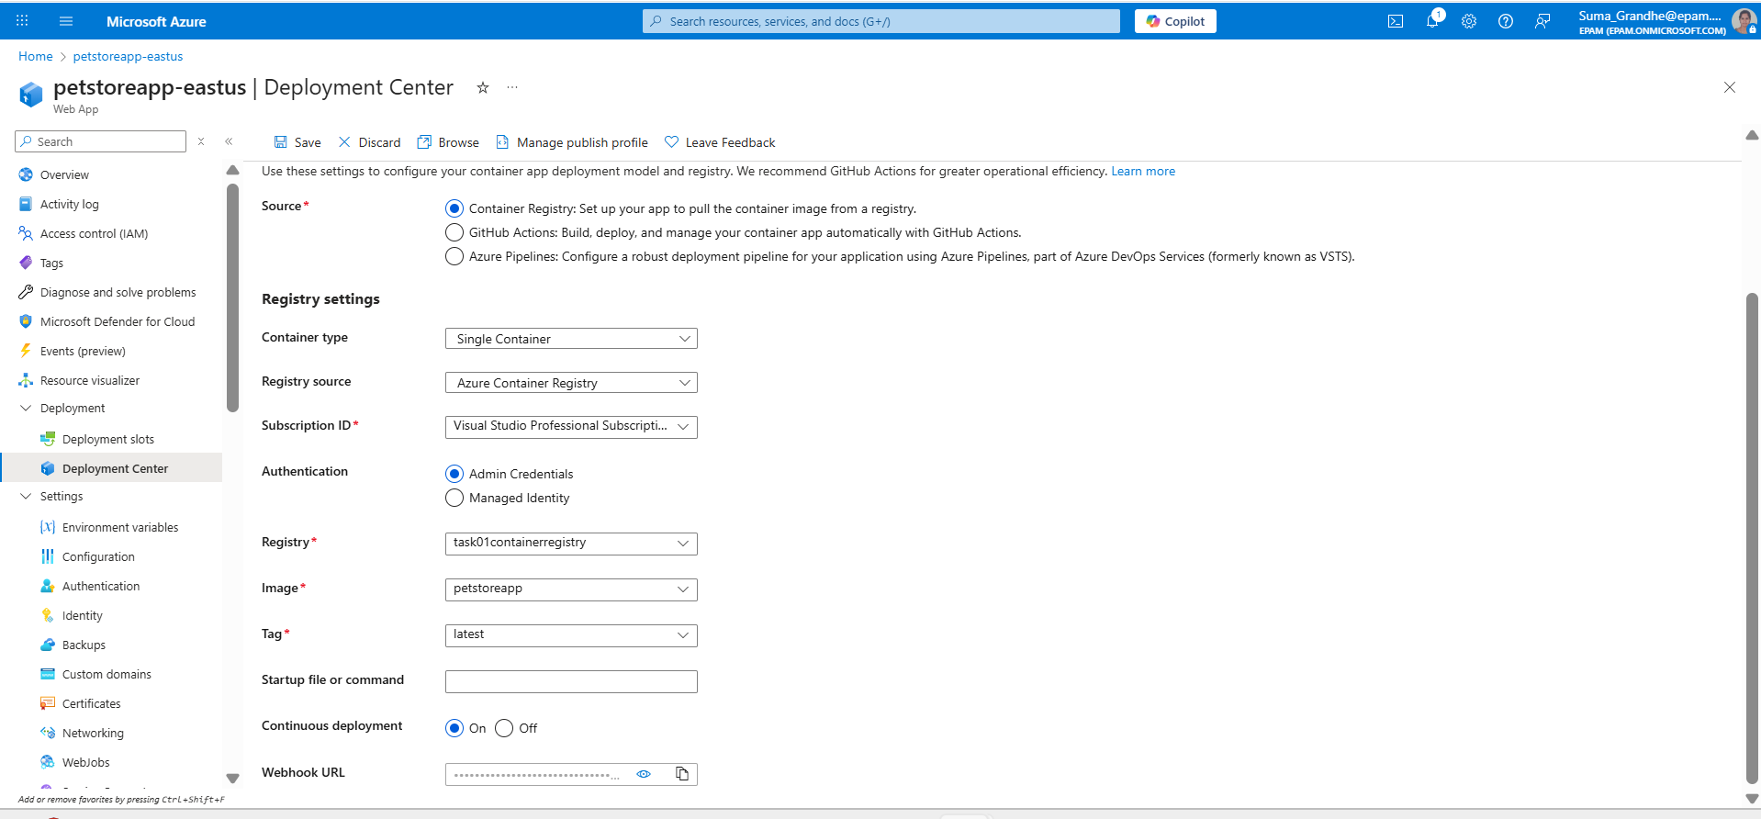Screenshot of successful push of an updated Docker image to the Azure Container Registry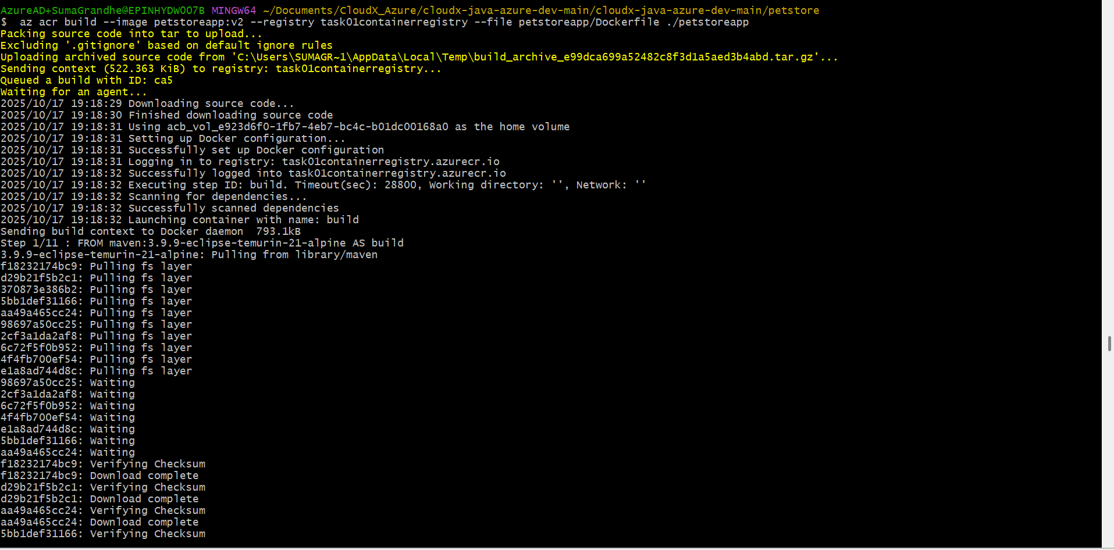

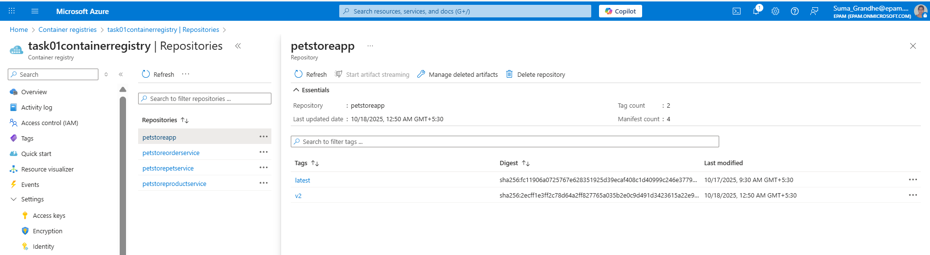

Screenshot of testing deployment slot and verification of changes

Screenshot of staging petstoreapp with changes

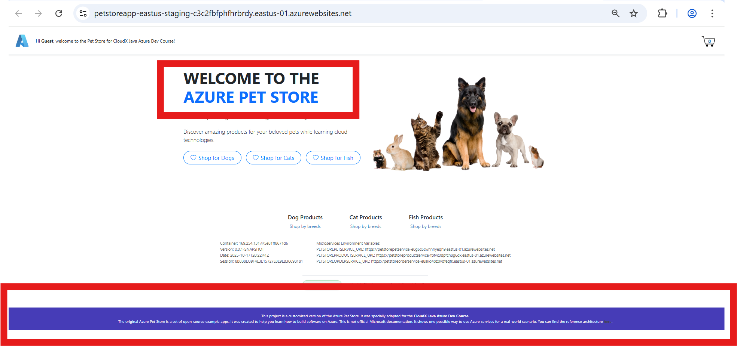

Screenshot of performing swap

Screenshot of staging petstoreapp post swap

Screenshot of production petstoreapp post swap

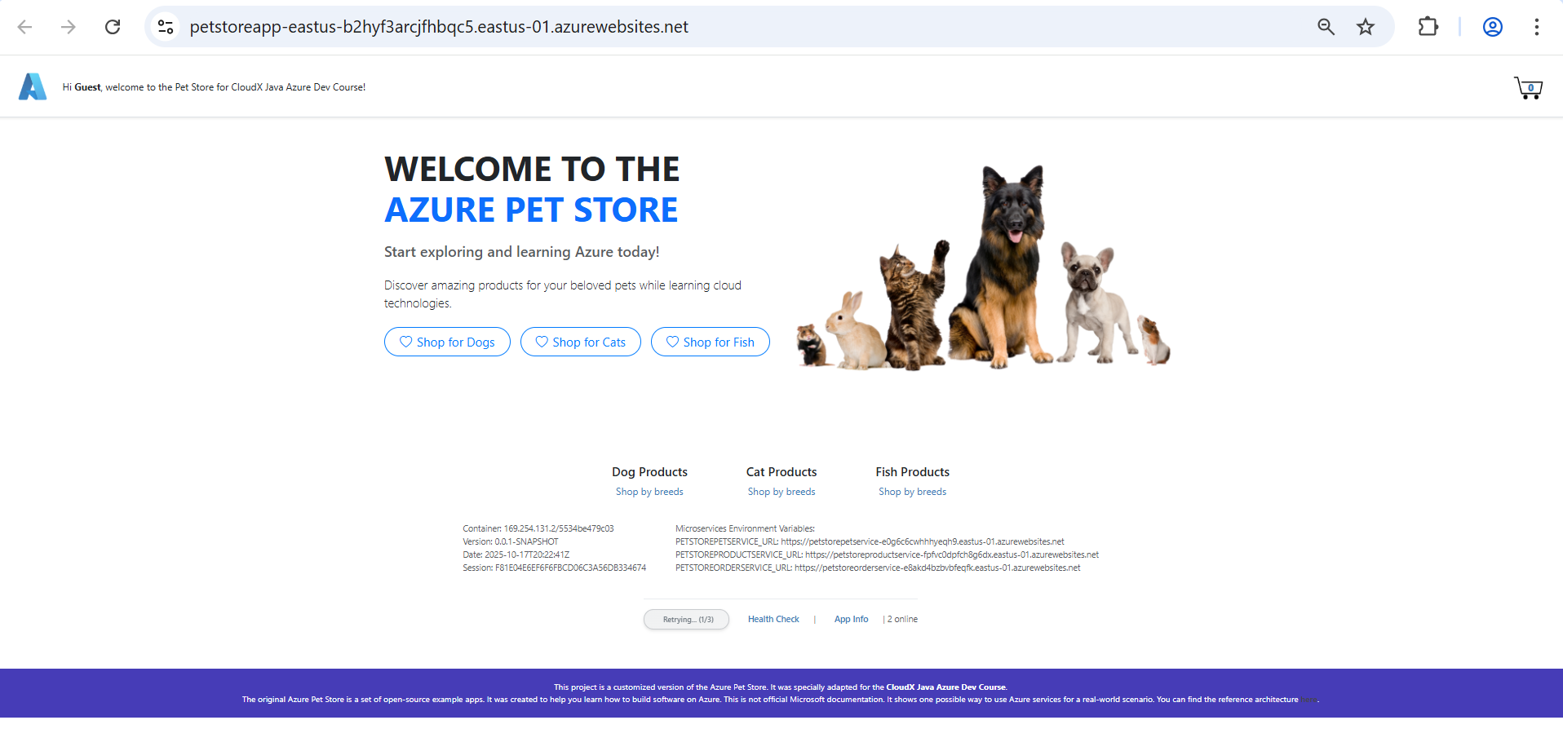

**6.Configure Traffic Manager**

Screenshot of the Azure portal creation of a Traffic Manager profile.

Addition of endpoints representing different PetStoreApp instances and configuration of health checks for endpoint availability.

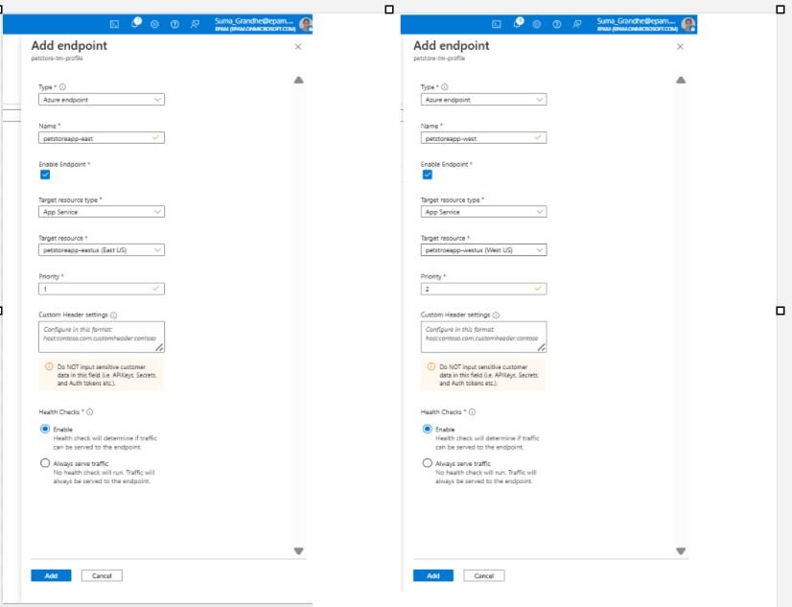

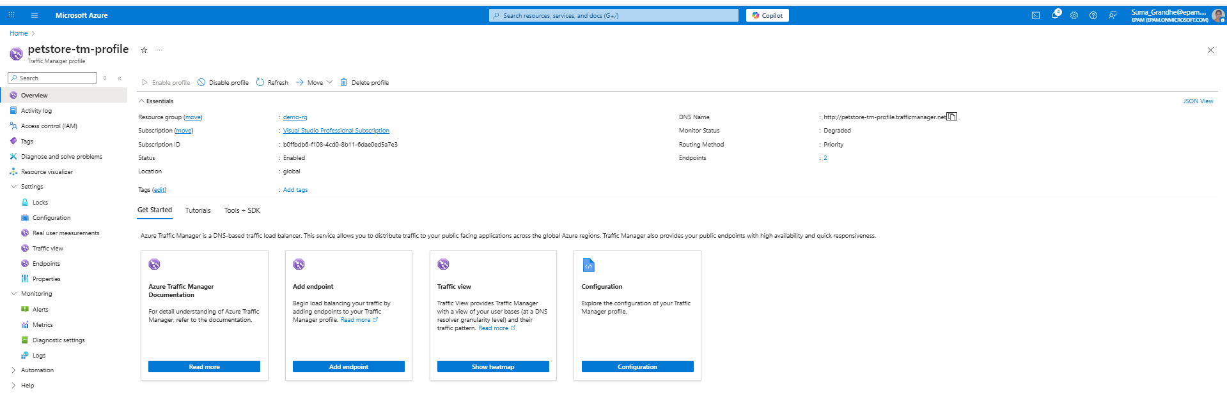

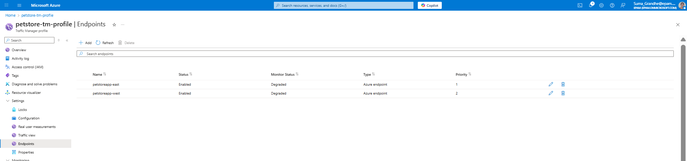

Screenshots of use of Traffic Manager URL to access the application.

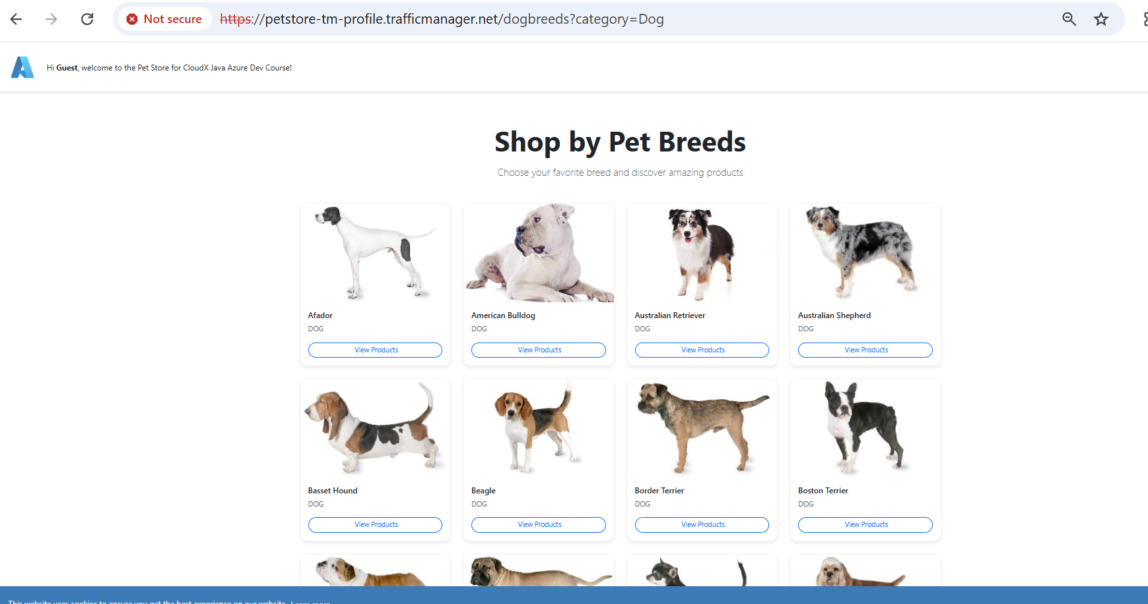

Video demonstrating the navigation of the PetppStore application utilizing a Traffic Manager Profile



screenshot showing the list of Azure resources

